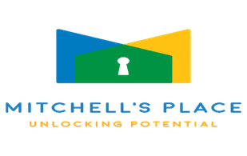
Central Alabama’s 11th
“Unlocking the Mystery of Developmental Disorders” Conference
Ticket and Registration Information:
Individual Registration: $125 each*
Group Discounts of 6 or more: $100 each*
(Contact Denise Gillespie below for details)

*Credit card payments will incur small processing fee

Breakfast items, coffee, and lunch are included with admission!

Registration information:
http://www.seccoconferences.com

**CEUs will be awarded!

** Purchase Orders accepted!! (Contact Denise Gillespie below)

Exhibitor Tables are Available! $150 for each Table and 1 Person (A 2ND person $50 per table). Visit www.seccoconferences.com or contact Denise Gillespie below to register!

Have any Questions?
Contact one of the organizers below:

Cindy Nelson: cnsecco16@gmail.com
205-356-7213
Denise Gillespie: seccodg@gmail.com
205-612-4458
Alice Murdoch: seccoalicem@gmail.com
205-447-8594

Brought to you by Special Education Consultants and Conference Organizers (SECCO) with support from MITCHELL’S PLACE

Date: Tuesday, Nov. 17, 2026
Place: Vestavia Hills Baptist Church
2600 Vestavia Drive
Birmingham AL 35216
Time: 8:00 a.m. to 3:00 p.m.
(Registration begins at 7:30 a.m.)

Speaker sessions to address topics such as:
*Feeding/Nutrition
*Sensory Teaching Ideas
*Applied Behavior Analysis
*Communication concerns
*Using Visual Supports to Reduce Behavior
*Legal Updates in Special Education
AND others!

For additional information visit:
http://www.seccoconferences.com
Check website frequently as we update for speakers etc.!

